VAMSI 192011429

EXPERIMENT 4

Data Link Layer Traffic Simulation using Packet Tracer Analysis of CSMA/CD & CSMA/CA

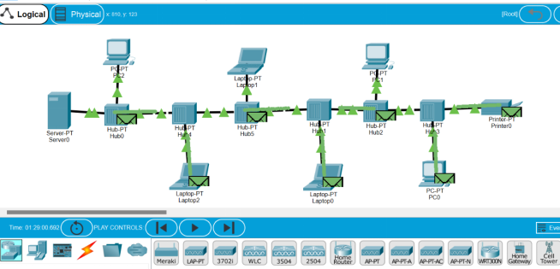

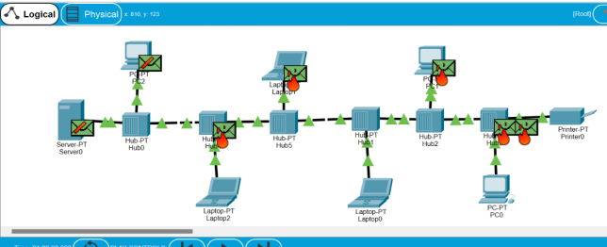

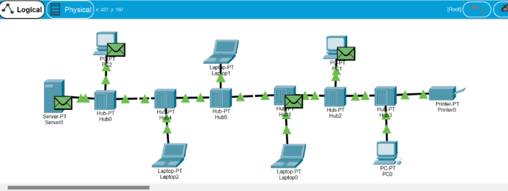

RESULT: we have gotten the result as excepted.